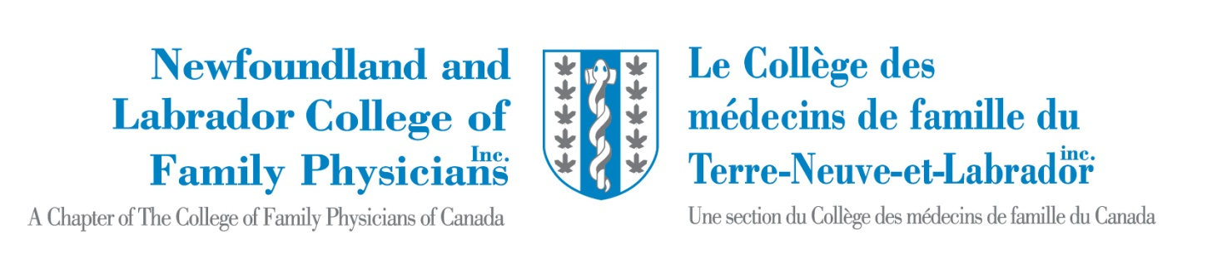 |  | NL CFPC  BOARD OF DIRECTORS
Policy Title: NLCFP Code of Conduct / Declaration |  | Policy # BOARD-17
Effective Date:  July 2023 | Authorized:  Board of Directors | To be reviewed:

The Newfoundland and Labrador College of Family Physicians (NL CFPC) Board of Directors has adopted this Code of Conduct to assist Directors in understanding and fulfilling their duties and obligations. It is not intended to be exhaustive of all matters and standards related to a director’s conduct.
Directors are encouraged to consult the Board Chair where they have a question or concern.
Board directors are champions and ambassadors of our discipline. They will be held to strict standards of honesty, good faith, integrity, and loyalty; they shall not put personal interests ahead of the best interests of the NLCFP (fiduciary duty). They must respect the confidentiality of information about the NLCFP.
Each Director has a duty to prepare for and attend meetings of the Board, or where he or she is not able to attend, provide due notice.
It is recognized that Directors bring diverse backgrounds, skills, and experiences. Directors will not always agree with one another on all issues. All debates shall take place in an atmosphere of mutual respect and courtesy. Directors shall participate in a spirit of co-operation and collegiality. The authority of the chair must be respected at all times. Directors have to respect the confidentiality of all decisions relating to the board and the voting result of those decisions. Directors should recognize that the NLCFP President, and Director of External Engagement are the official NLCFP spokespersons, with other members of the Executive Committee, as appropriate.
Each Director will exercise the degree of care, diligence, and skill that a reasonably prudent person would exercise in comparable circumstances. Directors shall comply with all applicable laws and regulations, including NLCFP’s bylaws and policies.
Each Director shall report any actual, potential or perceived conflict of interest situation as per the Conflict of Interest Policy and abide by the Board-determined management strategy, as applicable.

The following behaviours would be unacceptable and could be considered grounds for censure or removal from the NLCFP Board:
- shaming others for negative outcomes.
- using foul, abusive language.
- arbitrarily sidestepping policies.
- manipulating policies and procedures to block proceedings.
- acting in a way that could reasonably be perceived as harassment or discrimination.
- threatening others with retribution, litigation, or violence.
- criticizing staff in front of others (outside of in-camera board meetings).
- being disrespectful or discourteous.
- relying on intimidation to get his or her way.
- behaving in a way that is inconsistent with the NLCFP Values.
- behaving in a way that is contrary to applicable provincial or federal legislation.

Note, in situations involving complaints of workplace violence, harassment or discrimination against a Board Director, the NLCFP may be required to conduct an investigation and/or notify the police and/or applicable regulatory bodies.
Each Director shall sign the NLCFP Board Director Professional Conduct Declaration per term and adhere to this Code of Conduct. If a Board Director is deemed to have breached the Code of Conduct (see process below under Alleged Breaches), they agree to resign from the Board of Directors.
Alleged Breaches of the Code of Conduct:
Directors or CFPC members who believe that a provision of this Code has been breached should immediately report the matter in writing to the Chair of the Board. (If the Chair is implicated, the matter should be reported to the President-Elect). The Chair has discretion to determine whether the matter is sufficiently serious to warrant discussion by the entire Board. The Chair might choose to first address the matter directly with the Director(s) implicated and seek a resolution if possible. When the Chair determines the matter requires full discussion by the Board, the Chair will do the following:
- Notice: The Director who is alleged to have breached the Code will be given notice of the complaint or allegation against him or her, including the name of the complainant and other reasonable factual details to allow the individual to understand the basis and substance of the complaint.
- Response: A Director will be given five business days to provide a written response to the allegations. In exceptional circumstances, the Board Chair retains the discretion to lengthen the time for a response.
- Board Evaluation: The Board of Directors will consider the written submissions of the director whose conduct is being reviewed and render its decision in writing within 10 business days. The Board will render a decision on whether or not a breach of the Code of Conduct has occurred. The Director whose conduct is being reviewed shall not participate in the Board meeting called to consider the complaint.

- Remedies: The Board will consider each complaint on its merits. If the Board reaches a decision that a breach of the Code of Conduct has occurred, the Director whose conduct is being reviewed will be asked to resign from the Board of Directors.
Discussions are considered in-camera until step (e)
- In the case that this cannot be remedied within the Board, the issue will be shared with NLCFP members. In accordance with NL CFPC bylaws and the Not-for-Profit Corporations Act, members will be asked to reach a decision regarding the possible removal of the Director from the office.

Note: alleged issues will be dealt with, maintaining confidentiality, and respecting personal information for all persons involved in the complaint.
I hereby agree with the NLCFP Board Code of Conduct as outlined and approved by the NLCFP Board.

Name (print): Date:

Signature:

