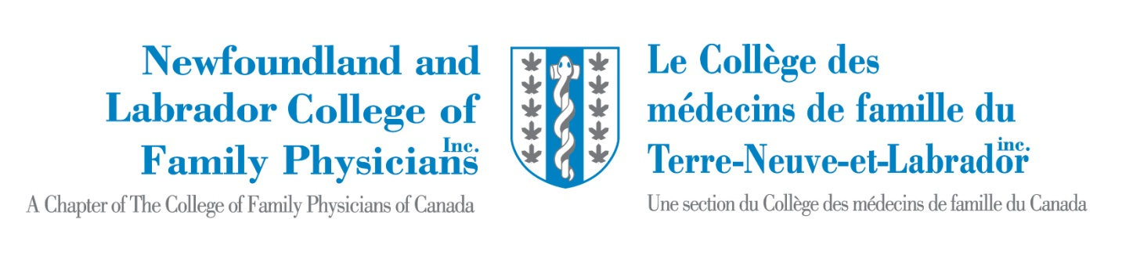
Minutes CFPC NL Chapter - 2013 AGM
Humber Valley Resort
October 18th, 2013
Attendance:
Dr. Charlene Fitzgerald Dr. Norah Duggan Dr. Jackie Elliott Dr. David Thomas
Dr. Trent Parsons Ms. Mimi Pukulalatt Dr. Lisa Kieley Dr. Lorena Power
Dr. Brent Thistle Dr. Edgar Mayo Dr. Aaron McKim Dr. Wendy Graham
Dr. Marie Beaulieu Dr. Roger Butler Dr. Robert Miller Dr. Cathy Maclean
Dr. Mohammed Aziz Dr. Jim Bowen Dr. Scott Moffatt Dr. Judy Ophel
Dr. Karen Horwood Dr. Mary O’Keefe Dr. Gary Tarrant Dr. David Blecher
Dr. Paul Bonisteel Dr. Danielle Phillips Dr. Sonny Collis Dr. Michael Jong
Dr. Roxanne Cooper Dr. Margo Wilson Dr. Steve Darcy Dr. Dave Morgan
Dr. Cheri Bethune Dr. Joy Tilley Dr. Jody Woolfrey Dr. Susan Avery
Dr. Jordan Karaniavov Dr. Pinos Mpiana Dr. Ian Simpson Dr. Louise Campbell
Dr. Annabeth Loveys Mr. Christopher Earle Dr. Michelle Hoque Dr. Nancy Simpson
Dr. Sammolu Beckley Dr. Greg Sherman Dr. Sandeep Mangat Ms. Yi Gloria Lin

- Call to Order
Meeting called to order by Dr. Charlene Fitzgerald at 1:25 PM.

- Introduction of Executive and Guests
Executive members were introduced. Dr. Marie Dominique Beaulieu, President National CFPC and Dr. Cathy Maclean, Chair, Family Medicine were introduced as special guests.

- Acceptance of Agenda
Agenda Accepted

- Approval of the Minutes AGM 2012
Motion to accept minutes by Dr. Paul Bonisteel and seconded by Dr. Greg Sherman.

- Annual Report of President
Dr. Fitzgerald presented her annual report. Discussed ASA and the call for presentations that were very successful. She also discussed our attempts to do a second CME event in the winter. Such an event was held with the NLMA AGM this year.
SOOS workshops have been improved and we hope to add a SAMP component.
ALSO courses continue and the flight team was trained this year.
Two new awards were presented this year- Dr. Fitzgerald mentioned the medical student and resident student award. Dr. Fitzgerald stated that there had been 4 submissions responding to that question from Dr. Bethune.
Charlene discussed the upcoming Prifor and PMH forum in November. She mentioned details for this forum and details of invitees. The goal of this forum will be to develop a working group for the PMH.
Medical school collaboration continues. Dr. Maclean had discussed with us that most other chapters have a representative from the discipline of family medicine. Dr. Fitzgerald mentioned that an amendment to the bylaws would likely be presented next year.
The NLMA recognized a motion to support the PMH model and this has moved forward at the NLMA Board level.
Dr. Fitzgerald discussed legislation for Not-for-Profit Organization groups including elections for National Board members. In the past it was just assumed that the president and past-president would be representatives.
The chapter office will be moving to the new medical school. No questions.
Motion to accept report from Dr. Jong and Dr. Moffatt.

- National Board Report
Dr. Jackie Elliott presented the national board report.
The PMH is a priority and there has been significant work done nationally and provincially. Lobbying to government on issues such as oxycodone, marijuana, issues with OCP, etc. Duty hour work continues.
Triple C rollout continues with evaluation of this curriculum. Special Interest/Focused Practice development has occurred. MainPro changes will be coming.
The harmonized LMCC II and CFPC exam occurred and initial feedback has been good.
Changes to the Not-for-Profit Organization legislation has occurred and has had impact on how we elect board members and will impact on bylaws.
National Global Health conference will be occurring again.
New award named after Dr. Calvin Gutkin.
FMF in Vancouver from November 7-9.
Dr. Paul Bonisteel asked about chapter presence in the North. Dr. Fitzgerald and Dr. Duggan stated that National Office are looking at how to best handle this.
Motion to accept by Dr. Sherman, seconded by Dr. Bonisteel.

- Annual Report of the Treasurer
Dr. Trent Parsons mentioned the new Not-for-Profit Organization legislation. He presented the Financial Statement ending December 31, 2012 with explanation. He mentioned the GIC and investment is no longer permitted. He explained the reasons for the surplus and the need to assign the funds to specific projects. Dr. Bonisteel asked if a bank account was considered an investment and if office equipment depreciation. Dr. Butler asked about a Board Fund to develop the boards skills and for discretionary expenses associated with being a board member. There was general agreement from the group on this idea. He also asked about the reserve level. Discussion ensued as to what this amount should be. Dr. Beaulieu suggested that a clear guideline from National College would be helpful.
Dr. Graham mentioned that the money assigned to the President’s Honorarium to travel to out of province ASAs and suggested it could be increased.
Dr. Parsons presented the ASA Year end Dec 2012. Discussion ensued.
Dr. Miller asked about implications of interactions with pharma at the ASA. Dr. Beaulieu said there would be rules to come in November 2013.
Motion to accept by Dr. Bonisteel, seconded by Dr. Roger Butler.

Dr. Parsons presented the Annual Budget Projection for 2014. Dr. Parsons also presented the Special Projects. Dr. Moffatt asked about the salary of our administrative support compared to other chapters.
Dr. Miller discussed the possibility of the chapter assuming more role of delivering CME across the province. He was supportive of our winter CME idea.
Dr. Bethune mentioned mentoring students both at our College Corner and at our winter ASA. Dr. Horwood suggested possibly attaching a CME event to Monte Carlo but issues with close timing to ASA.
Dr. Moffatt mentioned attaching to Actapath. Dr. Jong asked about arranging Atlantic Canada CME.
Motion to accept Annual Budget Projection for 2014 by Dr. Sherman, seconded by Dr. Cooper.

- Fracking Motion
Dr. Simpson presented his motion on fracking. He reported evidence from his own review of the data and his concerns over health concerns. Seconded by Dr. O’Keefe.
Discussion ensued with general support for the motion with a friendly amendment to state “We strongly recommend moratorium…” Motion carried. Dr. Bowen commended Dr. Simpson on his work.

- Nominations for vacant positions
Election of Officers- Dr. Roxanne Cooper and Dr. Elizabeth Mate Downer elected as members at large. Dr. Dave Thomas was elected National Board Member for the upcoming year.

- Adjournment
AGM was adjourned at 3PM

Respectfully submitted,

Dr. David Thomas
Honorary Secretary, NL CFPC

