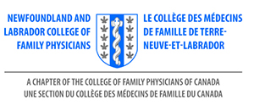
AGENDA
AMM - NL College of Family Physicians Inc.
Thursday, November 19, 2020
Virtual AMM – 7:30pm

- Call to Order
- Introduction of Executive Committee and Guests
- Appointment of Resolutions Committee – Dr. C. Patey
- Acceptance of Agenda
- Approval of Minutes – September 2019
- Annual Report of President – Dr. S. Collis
- Director of External Engagement – Dr. N. Stockley
- Annual Report of Treasurer –Dr. C. Patey / Dr. N. Stockley
- Nominations Committee – Elections – Dr. Stockley
- Election of Officers

President Elect / Honorary Secretary
- Resolutions
- Award Ceremony
- Family Physician of the Year & Award of Excellence
- Adjournment

