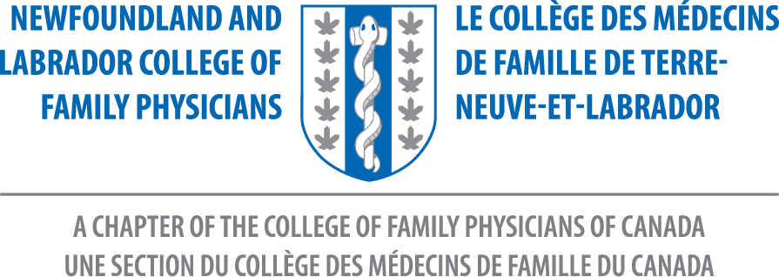

Minutes

Annual Members Meeting
NL College of Family Physicians
Saturday, September 28, 2019 – MEC, MUN

Present:

NL College of Family Physicians Board of Directors

Dr. Nicole Stockley Dr. Sonny Collis Dr. Shelley Sullivan
President President Elect Honorary Secretary

Dr. Pamela Doran Dr. Megan Hayes Dr. Chris Patey
Resident Rep-MUN Member at Large Member at Large

Dr. Elhamy Samak Dr. Parinita Verma Mr. Iqshvaku Mishra
Member at Large Resident Rep-MUN Med Student Rep-MUN

Dr. Katherine Stringer
Family Medicine Rep

Missing from the Board: Dr. Stephen Lee ( Honorary Treasurer), Ms. Hilary Strong (Medical Student Rep)

Dr. Taylor Anderson Dr. Colette Bartlett Dr. Melissa Bennett
Dr. Katie Bennett Dr. Roxanne Cooper Dr. Heather Cuddy Dr. Michael Cutler Dr. Steve Darcy Dr. Ryan Dean Ms. Maria Doyle Dr. Allison Drover Dr. Lynn Dwyer
Dr. Jackie Elliott Dr. Gerard Farrell Dr. Robert Forsey Dr. C. Fitzgerald Dr. Erin Fitzpatrick Dr. Marshall Godwin Dr. Wendy Graham Dr. Megan Greene Dr. Hany Hanein Dr. Ahmad Ibrahim Ms. Alana Jewell Dr. Emad Kamel
Dr. Paige Kendall Dr. David Kwinter Dr. Michele Levy Dr. Annabeth Loveys Dr. Katie MacDonald Dr. Terry Maher Dr. Steve Major Dr. Norah Duggan Dr. Hannah Milley
Dr. A. McCarthy Dr. H. MacWhinney Dr. Ihab Morgan
Dr. Omeshini Morkar Dr. Pinos Mpiana Dr. K. Ntambwe
Dr. Perry Osborne Dr. Ean Parsons Dr. Jennifer Perry
Dr. Danielle Phillips Ms. Fallon Piercey Dr. Amy Pieroway
Dr. Lyn Power Dr. Morag Ryan Dr. Joseph Sami
Dr. Hans Schaefer Dr. Gregory Sherman Dr. Shanda Slipp
Dr. Sarah Small Dr. Gordon Stockwell Dr. Allison Tennant
Dr. Amanda Tzenov

Apologies to those names I may have missed - signup sheet got lost at times during the meeting!

- Meeting Called to Order: 12:59 PM

- Introduction of Executive Committee and Guests

- Appointment of Resolutions Committee:
Dr. Chris Patey available to accept resolutions throughout meeting.

- Acceptance of Agenda: Dr. Norah Duggan and Dr. Steve Major

- Approval of Minutes - Gander, October 2018:
Approved and accepted by Dr. Shanda Slipp and Dr. Annette McCarthy

- Annual Report of President - Dr. Nicole Stockley
Provided an Overview of the last 12 months

The 1st Resolution presented in 2018 – Developed a College advocate. We needed more of a “voice” in policy development. A position was created – Government Liaison. This will allow regular contact with the Department of Health and maintain communication with the CFPC. Also provides regular contact with NLMA. Dr. David Thomas accepted this position when recommended by the NL CFPC Board. He is absent today but has met with the Director of Primary Health Care, Cassie Chisholm. He has been an advocate for Family Medicine on Government Committees. Actively involved with both National CFPC and Provincial Chapters.

Family Medicine Promotion and Encouraging Engagement among members –
- Family Doctor Day – May 19, 2019
Ads were run on social media and in The Telegram. A Facebook Campaign to promote Family Doctor Day was a great place where many comments were posted. All were positive and great to see!

- 2 new awards
- My NL Family Doctor Award – borrowed from the BC Chapter. Patients nominated family doctors. 33 letters received for 20 different nominations. This was advertised in The telegram, social media and local municipalities.

- The Mohamed Ravalia IMG Award – NL is unique to have this award! Dr. Ravalia was very honored and humbled to be the first recipient of this award.
Learner Supports – Fridays with Family, Orientation Lunch and Social with Residents, Procedures Day with medical students, Core Content Socials with Residents, ALARM, CME’s, SOOs Workshop Spring 2019.

Developed and refinement of Chapter Policies and Committees.

Supported National Endeavors
Presence at National meetings – videoconferences, FMF November 2018, National CFPC Symposium ( Nov, Feb , May). St. John’s hosted February meeting.

Dr. Stockley expressed many thanks for the support of board members and members during her 2 years as President. Many thanks to Debbie Rideout for her support and hard work!

- Annual Report of Treasurer Dr. Nicole Stockley
Dr. Stephen Lee unable to continue as Honorary Treasurer for a third term.

Highlights:
Cash on Hand – Approximately $170000, $50000 in savings account/ Accounts Receivable - Assets/ Net Assets equal out

Revenue - $83000 membership Fees, Transfer from National, FMF Surplus, ALARM is cost neutral

Expenses – New Government Liaison Position - $1000, FMC budget for a loss, changed office insurance, supported medical student cost to attend FMC, new computers

Projected Budget – Membership fees have changed in when and how they are paid due to changes and National. $29000 deficit due to timing changes of paid membership fees.
Treasurer’s report accepted by Dr. Perry Osbourne and Dr. Gordon Stockwell

- Nominations Committee - Elections - Dr. Sonny Collis
2 Board positions available – Member At Large and Honorary Treasurer

- Election of Officers
Member At Large – Dr. Danielle Phillips nominated by Dr. Megan Hayes. No other nominations from the floor. Dr. Phillips acclimated and accepted position.

Honorary Treasurer – Dr. Chris Patey nominated by Dr. Sonny Collis. No other nominations. Dr. Patey accepted the position.

- Installation of New President
National CFPC President Dr. Paul Sawchuk present for installation.
Congratulations to our new President, Dr. Sonny Collis

- Resolutions – none received

- Adjournment – Meeting adjourned at 13:42

Respectively submitted,

Shelley Sullivan, MD, CCFP
Honorary Secretary
NL CFPC

