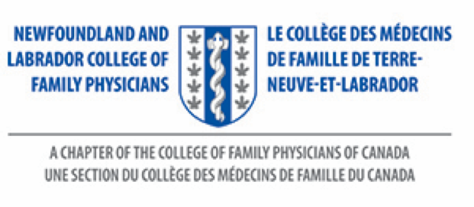

My NL Family Doctor Award
Nominee Information Form

Your Name:

Your Mailing Address:

Your Town/City Where You Live:

Your Telephone Number:

Your Family Doctor’s Name:

Your Email Address (if you have one):

If my family doctor receives an award, I give my permission for the NL College of Family Physicians to use my name, along with the letter written, to recognize my doctor’s work.

Yes
No

Ms. Debbie Rideout
Administrator
NL College of Family Physicians Inc.
Family Medicine, Room 2713A
Health Sciences Centre
300 Prince Philip Drive
St. John’s, NL
A1B 3V6
Tele: 709-864-6566
Website: nl.cfpc.ca
Email: drideout@nlcfp.ca

