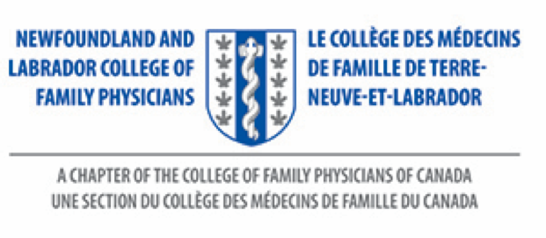
CHAPTER NOMINATION FORM

The Mohamed Ravalia IMG Award

Chapter:
Date:
Submitted by:

1. Nominee:

2. Address:

3. Membership # & Category:
(to be completed by NL CFP Administrator)

4. Supporting documents: Attached | Yes No
To follow | Yes No

Ms. Debbie Rideout
Administrator
NL College of Family Physicians Inc.
Family Medicine, Room 2713A
Health Sciences Centre
300 Prince Philip Drive
St. John’s, NL
A1B 3V6
Tele: 709-864-6566
Website: nl.cfpc.ca
Email: drideout@nlcfp.ca

