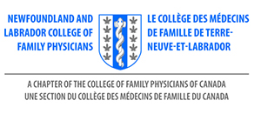
AGENDA
AMM - NL College of Family Physicians Inc.
Thursday, November 18, 2021
Virtual AMM – 7:30pm

- Call to Order
- Introduction of Executive Committee and Guests
- Appointment of Resolutions Committee – Dr. C. Patey
- Acceptance of Agenda
- Approval of Minutes – November 2020
- Annual Report of President – Dr. S. Collis
- Director of External Engagement – Dr. N. Stockley
- Annual Report of Treasurer –Dr. S. Sullivan
- Nominations Committee – Elections – Dr. S. Collis
- Election of Officers

Members at Large x 2
- Resolutions
- Installation of President – Dr. B. Bouchard
- Adjournment

