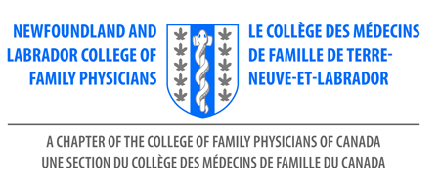

NL CFP Award of Recognition

This is an internal award whereby the NL CFP Board can nominate and acknowledge an individual or organization.

Eligibility :
- Recipients must be licensed to practice in Newfoundland and Labrador (where applicable)
- Recipients must be in good standing with their relevant governing body

Criteria:
- An individual or organization who has shown a special contribution to Family Medicine in NL.

Selection Process:
- Nominations are invited from NL CFP Board Members.
- Nominations must be submitted to the NL College of Family Physicians office by email or mail, as listed on the nomination form below.
- Deadline for submissions: June 30, 2022
- The NL CFP Board / Awards Committee will identify the recipient of this award.

Value:
- Recipients will be invited to receive the award at the NL CFP Celebration of Family Medicine event.
- Recipients will receive two complimentary dinner tickets to attend the Celebration of Family Medicine.
- Recipients will receive complimentary registration to attend the NL CFP Family Medicine Conference. (where applicable)
- Recipients will receive a physical award during the Celebration of Family Medicine.

NOMINATION FORM

NL CFP Award of Recognition

Deadline: June 30, 2022

Send to NL Chapter: | Debbie Rideout, Administrator  NL College of Family Physicians Inc  drideout@nlcfp.ca
Nominator Name:

Contact Information for Nominator Including Email Address

Name - Nominee | Address / Email Address
1.
*

*Reason for nomination:

*The reason for the nomination is required.

Please use this form to submit your nominations to:
drideout@nlcfp.ca

NL College of Family Physicians Inc.
Room 2713A, Family Medicine
300 Prince Philip Drive
St. John’s, NL A1B 3V6
(709) 864-6566

