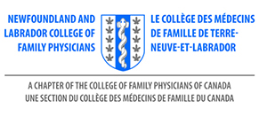

AGENDA

AMM - NL College of Family Physicians Inc.
Thursday, October 22, 2022
Face to Face Meeting– 1:00pm

- Call to Order
- Introduction of Executive Committee and Guests
- Appointment of Resolutions Committee – Dr. C. Patey
- Acceptance of Agenda
- Approval of Minutes – November 2021
- Annual Report of President – Dr. C. Patey
- Annual Report Director of External Engagement – Dr. N. Stockley
- Annual Report of Treasurer –Dr. S. Sullivan
- Nominations Committee – Dr. S. Collis
- Resolutions
- Adjournment

