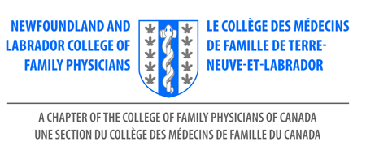
Resolution Raising Membership Dues $50

WHEREAS, the Newfoundland and Labrador Chapter of the College of Family Physicians invoices members for dues on an annual basis;

WHEREAS, the Chapter budget is largely driven by receipt of dues;

WHEREAS, the last membership fee increase was in 2011;

WHEREAS, The Chapter continues to seek out and capitalize on every opportunity to be "a voice at the table” in the province through our Director of External Engagement position

WHEREAS, The Chapter continues to increase our presence with Medical Students and Residents with in-person events

WHEREAS, The Chapter endeavors to continue to provide a Family Medicine Conference, and other events to NL members as accesible/low-priced events

WHEREAS, The Chapter wants to continue to promote Family Physicians in our province.

NOW, THEREFORE, BE IT RESOLVED, that the Newfoundland and Labrador Chapter of the College of Family Physicians will raise its annual membership dues by $50

Presented by the Board of the Newfoundland and Labrador Chapter of the College of Family Physicians
for the 2022 Annual Members Meeting.

