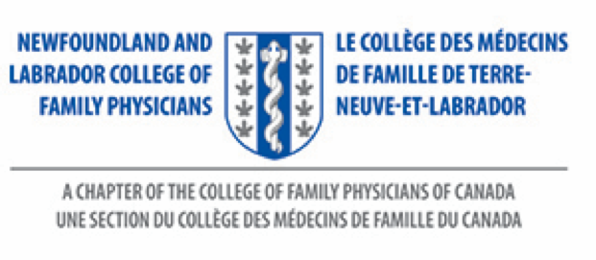
My NL Family Doctor Award
Nominee Information Form
Deadline: June 1, 2023

Your Name:

Your Mailing Address:

Your Town/City Where You Live:

Your Telephone Number:

Your Family Doctor’s Name:

Your Email Address (if you have one):

By nominating my family doctor for this award, I give my permission for the NL College of Family Physicians to use my name, along with the letter written, to recognize my doctor’s work.
Yes
No

Signature:_______________________________

Ms. Debbie Rideout
Administrator
NL College of Family Physicians Inc.
Family Medicine, Room 2713A
Health Sciences Centre, 300 Prince Philip Drive
St. John’s, NL A1B 3V6
Tele: 709-864-6566
Website: nl.cfpc.ca
Email: drideout@nlcfp.ca

