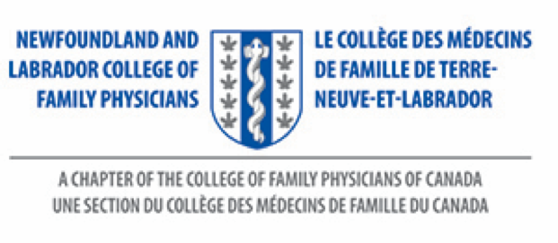
NL CFP Family Medicine Resident Award

This award recognizes a MUN Family Medicine Resident who stands out above other residents as per criteria listed below.

Eligibility :
- Recipients must be licensed to practice in Newfoundland and Labrador
- Recipients must be in the MUN Family Medicine Residency Program
- Recipients must be in good standing with CPS NL

Criteria:
- Practices or demonstrates one or more of the following:
- Kindness, thoughtfulness and good communication with peers and patients
- Professionalism in daily work
- Exceptional teacher
- Exceptional leadership skills

Selection Process:
- Nominations are invited from MUN Medical Students, Preceptors, another resident in Family Medicine or another MUN program.
- Nominations must be submitted to the NL College of Family Physicians office by email or mail, as listed on the nomination form below.
- Deadline for submissions: June 1, 2023
- The NL CFP Board will identify the recipient of this award.

Value:
- Recipients will be invited to receive the award at the NL CFP Celebration of Family Medicine event.
- Recipients will receive two complimentary dinner tickets to attend the Celebration of Family Medicine.
- Recipients will receive complimentary registration to attend the NL CFP Family Medicine Conference.
- Recipients will receive $750 to help assist with expenses to attend the Celebration of Family Medicine and receive the physical award. This money will only be issued if the resident can attend the Celebration to receive award.
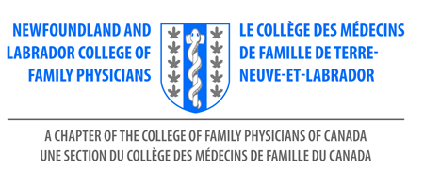
NOMINATION FORM

NL CFP Family Medicine Resident Award

Deadline: June 1, 2023

Send to NL Chapter: | Debbie Rideout, Administrator  NL College of Family Physicians Inc  drideout@nlcfp.ca
Nominator Name:

Contact Information for Nominator Including Email Address

Name - Nominee | Address / Email Address
1.
*

*Reason for nomination:

Please use this form to submit your nominations to:
drideout@nlcfp.ca

NL College of Family Physicians Inc.
Room 2713A, Family Medicine
300 Prince Philip Drive
St. John’s, NL A1B 3V6
(709) 864-6566

