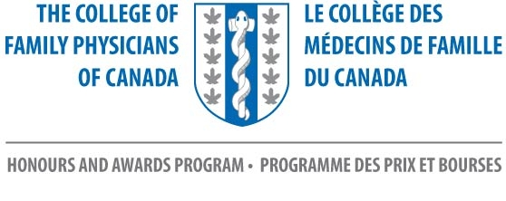
NL College of Family Physicians - NOMINATION FORM

The Mohamed Ravalia IMG Award

Deadline: June 1, 2023

Send to NL Chapter: | Debbie Rideout, Administrator  NL College of Family Physicians Inc  drideout@nlcfp.ca
Nominator Name:

Contact Information for Nominator Including Email Address

Name - Nominee | Address / Email Address
1.
*

*Reason for nomination:

*The reason for the nomination is required.
Please attach CV of nominee to the nomination form.

Please use this form to submit your nominations to:
drideout@nlcfp.ca

NL College of Family Physicians Inc.
Room 2713A, Family Medicine
300 Prince Philip Drive
St. John’s, NL A1B 3V6
(709) 864-6566

