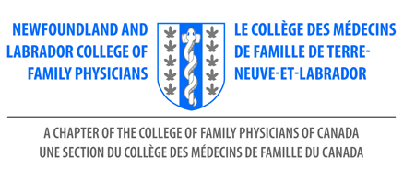

NLCFP First Five Years in Family Practice Award

The annual First Five Years in Family Practice Award is designed to recognize an exceptional family physician in the early stage of their career.

Eligibility:
- Recipients must be licensed to practice in Newfoundland and Labrador
- Recipients must be in good standing with their relevant governing body
- Previous award recipients are not eligible to receive the award again

Criteria:
- This award will be awarded annually to family physicians in their first five years of practice
- Locum family physicians are eligible for this award

The successful nominee is someone who:
- Practises comprehensive family medicine with a focus on continuity of care
- Actively demonstrates the value of physician wellness

The successful nominee may also demonstrate active involvement in or commitment to any of the following:
- Leadership – such as committee membership at a local, provincial, or national level
- Community involvement, including volunteerism, activism, or advocacy
- Research or quality improvement
- Teaching – this may be formal or informal and can include teaching patients, learners or colleagues
- Policy development

Selection Process:
- Nominations are invited from any member of the NLCFP.
- Nominations must be submitted to the NL College of Family Physicians office by email or mail
- Deadline for submissions: June 1, 2024
- The NLCFP Board / Awards Committee will identify the recipient of this award.

Value:
- Recipient will be invited to receive the award at the NLCFP Celebration of Family Medicine event
- Recipient will receive two complimentary dinner tickets to attend the Celebration of Family Medicine
- Recipient will receive complimentary registration to attend the NLCFP Family Medicine Conference
- Recipient will receive a physical award during the Celebration of Family Medicine
- Recipient will be reimbursed up to a maximum of $750 for expenses to attend the FMC/Celebration

NOMINATION FORM

NLCFP First Five Years in Family Practice Award
Deadline: June 1, 2024

Send to NL Chapter: | Debbie Rideout, Administrator  NL College of Family Physicians Inc  drideout@nlcfp.ca
Nominator Name:

Contact Information for Nominator Including Email Address

Name - Nominee | Address / Email Address
1.
*

*Reason for nomination – Please email us with a brief paragraph on why you feel your nominee should receive the First Five Years in Family Practice Award. Letters of support are welcome.

*The reason for the nomination is required.
Please use this form to submit your nominations to:
drideout@nlcfp.ca

