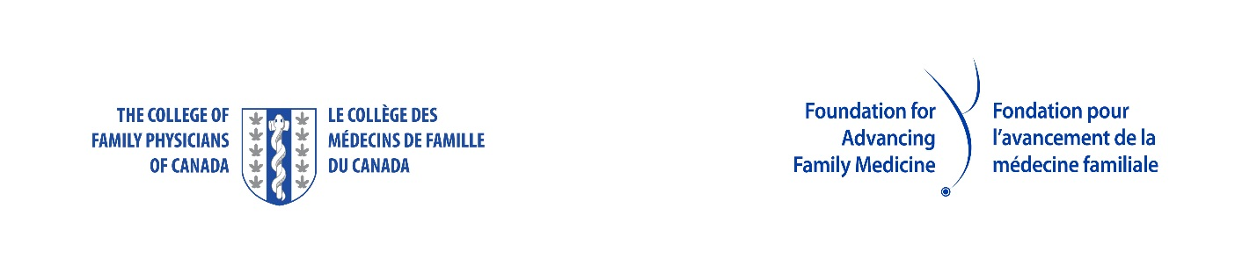

NL College of Family Physicians - NOMINATION FORM

CANADA'S FAMILY PHYSICIAN OF THE YEAR – REG L. PERKIN AWARD

Deadline: May 1, 2026

Send to NL Chapter: | Debbie Rideout, Administrator  NL College of Family Physicians Inc  drideout@nlcfp.ca
Nominator Name:

Contact Information for Nominator Including Email Address

Name - Nominee | Address / Email Address
1.
*

List supporting documentation:
1)
2)
3)
4)
5)

We ask that all supporting documentation accompany the nomination, such as résumés; testimonials from patients, colleagues, and community leaders; published reports; news clippings; letter from the nominator; photos; etc.

Please use this form to submit your nominations to:
drideout@nlcfp.ca

NL College of Family Physicians Inc.
Room 2713A, Family Medicine
300 Prince Philip Drive
St. John’s, NL A1B 3V6
(709) 864-6566

